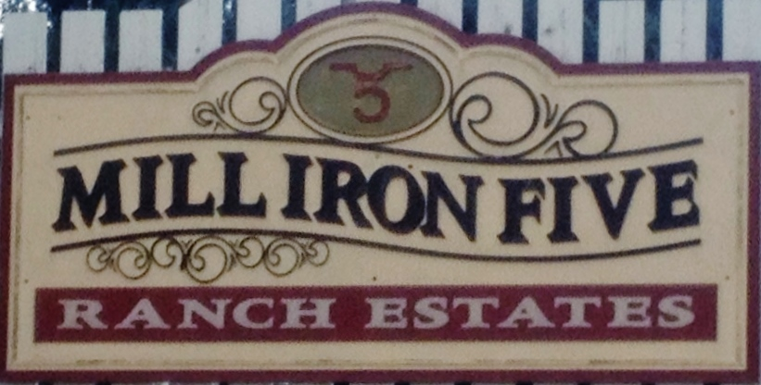

Mill Iron 5 Ranch Estates

March 31, 2021
RE: Annual HOA Meeting on March 4th, 2021

Present: Suzanne Malm, Trent Malm, Paula Rodriguez, Ron Roberts, Chad Walter, Cheryl
Olson, Brad Olson, Drew Guffey, Fred Martin, Grace Martin, Al Kammerzell, Karen
Kammerzell, Karol Dunshee, Carol Dunshee, Mark Morris, Brennan Bridge, Joe Browning,
Brenda Browning, Karen Parker, Denise Flores, Gina Kohler, Matt Kohler, Tom Coseo.

Budget: Paula talked about last years budget, updated budget and Profit and Loss
comparison. These complete papers will be on the new Mill Iron 5 Ranch Estates website.
Paula sent out an invitation to everyone to join MillIron5estates.CommunitySite.com where the
Covenants, bylaws, subdivision plat, Board Member info, Water board member info and
Community information will be. The dues will remain the same at $575 for 2021.

-Neighborhood Upkeep: There was discussion on refreshing both entrances and how to
pay for the upgrades. There is money in the budget for this and not all of the money to
replace dead trees was used last year. There was talk about phasing in upgrades so
we wouldn’t have to come up with the money all at once. Carol Dunshee and Drew
Guffey will be forming a committee for beautification of our neighborhood.
Anyone wanting to be a part of this committee is welcome to contact either Carol or Drew.
It was noted that there is no water or electricity at the west entrance.
Fred Martin discussed the need on following through with covenant violation notices. There
was also discussion on notifying neighbors with dead trees in their yard.

Water: The water fee will be based on square footage watered just as it was last year.
Paula Rodriguez was able to secure water from UNC again this year. Last year we had to
purchase more water and we will try and get on this earlier in the year. Mark Morris talked
about the pond and the water committee has talked about lining the pond or increasing
the size. There was discussion about further evaporation of water in the pond if the
pond was increased in surface area. The water committee continues to work on checking
the pond for erosion around the walls of the pond and the best way to manage it.

The water fees will be kept in a separate account, as it was last year, and the purchase price or
for the water will be passed on to the homeowners. Ron Roberts talked about the need for a
new hose in the pond because a piece of rebar put a hole in it. No major leaks are present at
this time.

Mill Iron 5 HOA Board: The Board was voted on and will remain the same.
President: Ron Roberts
Vice President: Fred Martin
Treasurer: Paula Rodriguez
Secretary: Suzanne Malm

Sadly, Kevin Hegstad passed away 3 days prior to our meeting. Chad Walters will be
replacing him on the Architectural Review Board

There was no new information on the proposed natural gas compressor station.

This last year was a good one for our community and I look forward to another good
year in Mill Iron 5. If you have any concerns or recommendations or would like to
help out, please don’t hesitate to call anyone on the Board.

Thank You,

Suzanne Malm
Secretary Mill Iron 5 Estates

